|  |  |  |  |  |
| --- | --- | --- | --- | --- |
| **Test Case** | **Input** | **Expected Output** | **Actual Output** | **Pass/Fail** |
| 1a | 1, a | You selected Pop Apr 1  The statistics for this column are:  count 5.570000e+02  mean 5.655731e+04  std 1.581271e+05  min 1.351900e+04  25% 3.195300e+04  50% 4.297900e+04  75% 6.170000e+04  max 3.726157e+06  Name: Pop Apr 1, dtype: float64  The histogram can be downloaded below | You selected Pop Apr 1  The statistics for this column are:  count 5.570000e+02  mean 5.655731e+04  std 1.581271e+05  min 1.351900e+04  25% 3.195300e+04  50% 4.297900e+04  75% 6.170000e+04  max 3.726157e+06  Name: Pop Apr 1, dtype: float64  The histogram can be downloaded below | Pass |
| 1b | 1, b | You selected Pop Jul 1  The statistics for this column are:  count 5.570000e+02  mean 5.575848e+04  std 1.360865e+05  min 1.261900e+04  25% 3.212000e+04  50% 4.354500e+04  75% 6.169300e+04  max 3.195153e+06  Name: Pop Jul 1, dtype: float64  The histogram can be downloaded below | You selected Pop Jul 1  The statistics for this column are:  count 5.570000e+02  mean 5.575848e+04  std 1.360865e+05  min 1.261900e+04  25% 3.212000e+04  50% 4.354500e+04  75% 6.169300e+04  max 3.195153e+06  Name: Pop Jul 1, dtype: float64  The histogram can be downloaded below | Pass |
| 1c | 1, c | You selected Change Pop  The statistics for this column are:  count 557.000000  mean -798.829443  std 22711.352870  min -531004.000000  25% -1338.000000  50% -196.000000  75% 1294.000000  max 22363.000000  Name: Change Pop, dtype: float64 | You selected Change Pop  The statistics for this column are:  count 557.000000  mean -798.829443  std 22711.352870  min -531004.000000  25% -1338.000000  50% -196.000000  75% 1294.000000  max 22363.000000  Name: Change Pop, dtype: float64 | Pass |
| 2a | 2, a | You selected AGE  The statistics for this column are:  count 10042.000000  mean 47.219478  std 23.149799  min -9.000000  25% 34.000000  50% 49.000000  75% 63.000000  max 93.000000  Name: AGE, dtype: float64 | You selected AGE  The statistics for this column are:  count 10042.000000  mean 47.219478  std 23.149799  min -9.000000  25% 34.000000  50% 49.000000  75% 63.000000  max 93.000000  Name: AGE, dtype: float64 | Pass |
| 2b | 2, b | You selected BEDRMS  The statistics for this column are:  count 10042.000000  mean 2.709221  std 1.066036  min 0.000000  25% 2.000000  50% 3.000000  75% 3.000000  max 7.000000  Name: BEDRMS, dtype: float64 | You selected BEDRMS  The statistics for this column are:  count 10042.000000  mean 2.709221  std 1.066036  min 0.000000  25% 2.000000  50% 3.000000  75% 3.000000  max 7.000000  Name: BEDRMS, dtype: float64 | Pass |
| 2c | 2, c | You selected BUILT  The statistics for this column are:  count 10042.000000  mean 1966.952201  std 26.305831  min 1919.000000  25% 1950.000000  50% 1970.000000  75% 1985.000000  max 2012.000000  Name: BUILT, dtype: float64 | You selected BUILT  The statistics for this column are:  count 10042.000000  mean 1966.952201  std 26.305831  min 1919.000000  25% 1950.000000  50% 1970.000000  75% 1985.000000  max 2012.000000  Name: BUILT, dtype: float64 | Pass |
| 2d | 2, d | You selected ROOMS  The statistics for this column are:  count 10042.000000  mean 5.723262  std 1.876209  min 1.000000  25% 4.000000  50% 6.000000  75% 7.000000  max 14.000000  Name: ROOMS, dtype: float64 | You selected ROOMS  The statistics for this column are:  count 10042.000000  mean 5.723262  std 1.876209  min 1.000000  25% 4.000000  50% 6.000000  75% 7.000000  max 14.000000  Name: ROOMS, dtype: float64 | Pass |
| 2e | 2, e | You selected UTILITY  The statistics for this column are:  count 10042.000000  mean 189.585964  std 128.928766  min 0.000000  25% 99.666667  50% 172.000000  75% 253.500000  max 1107.583333  Name: UTILITY, dtype: float64 | You selected UTILITY  The statistics for this column are:  count 10042.000000  mean 189.585964  std 128.928766  min 0.000000  25% 99.666667  50% 172.000000  75% 253.500000  max 1107.583333  Name: UTILITY, dtype: float64 | Pass |

**Test Cases and Screen Shots**

**1A**

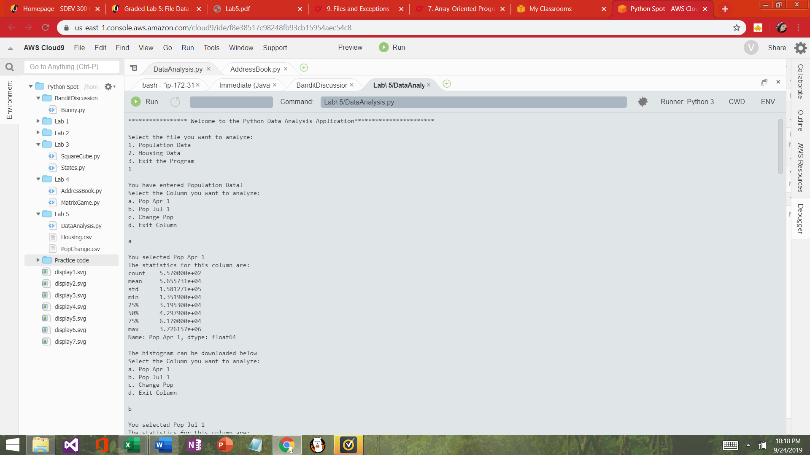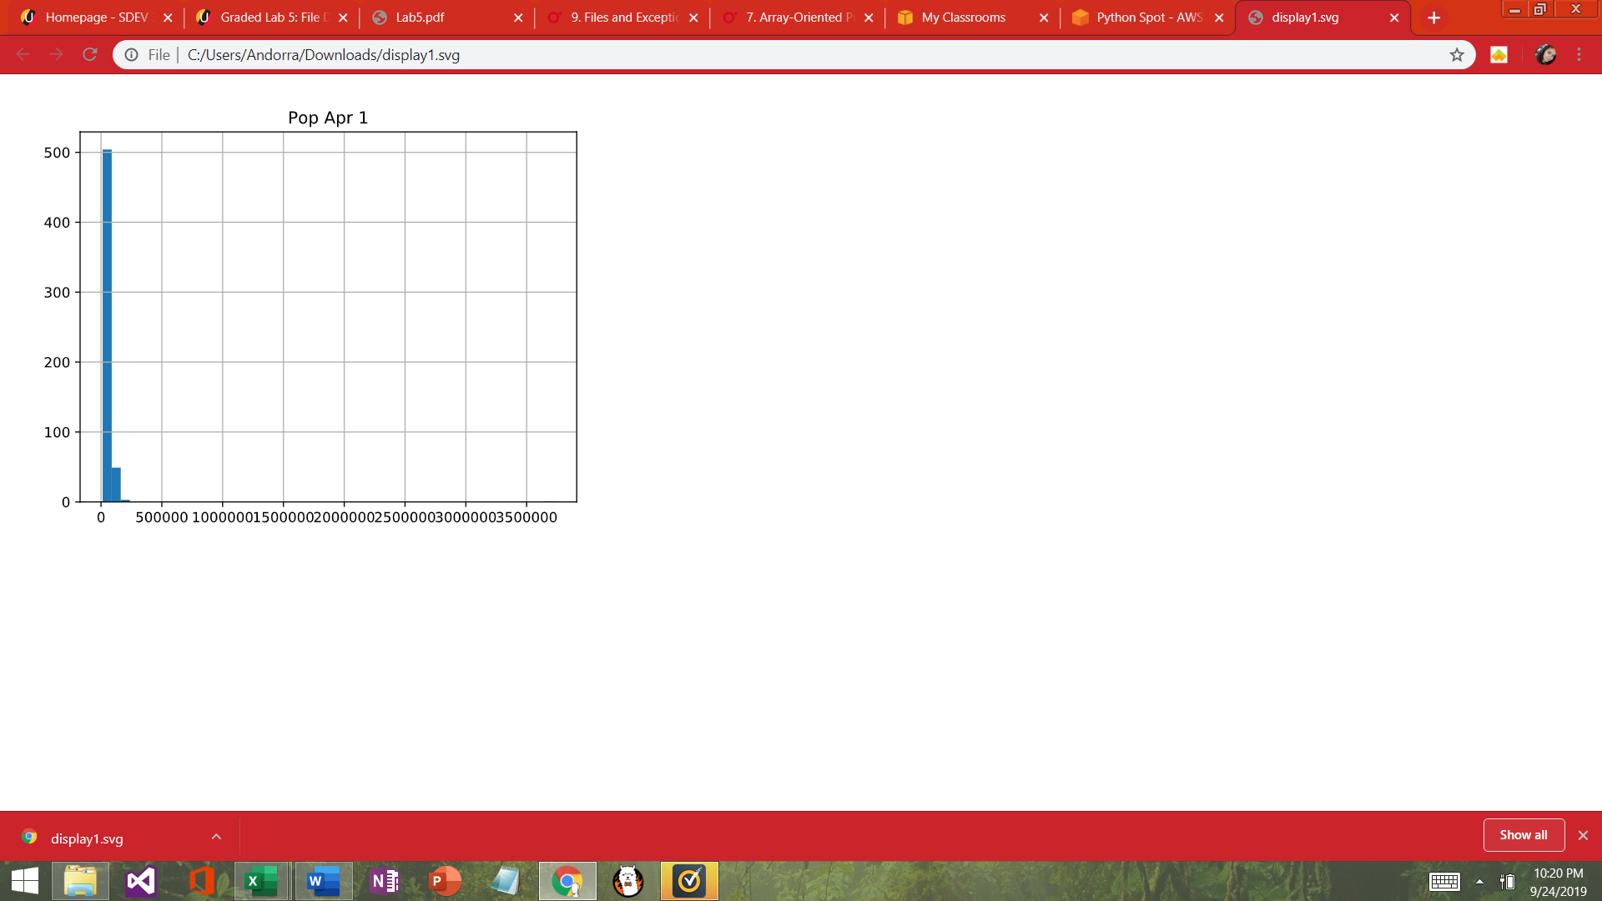

**1B**

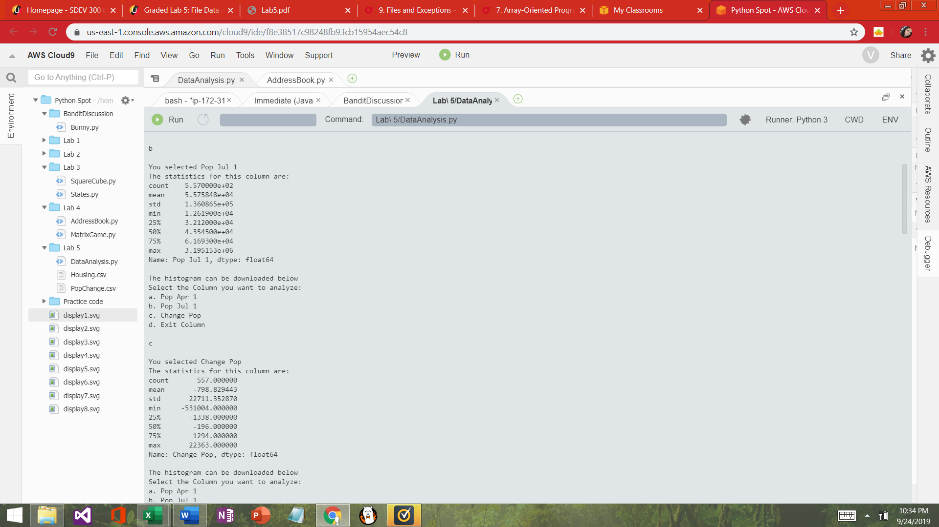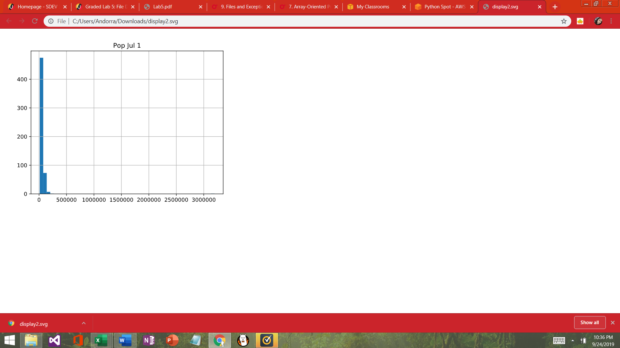

**1C**

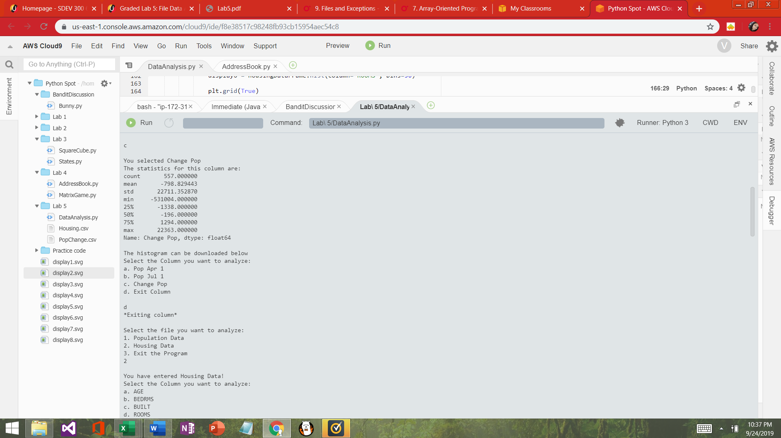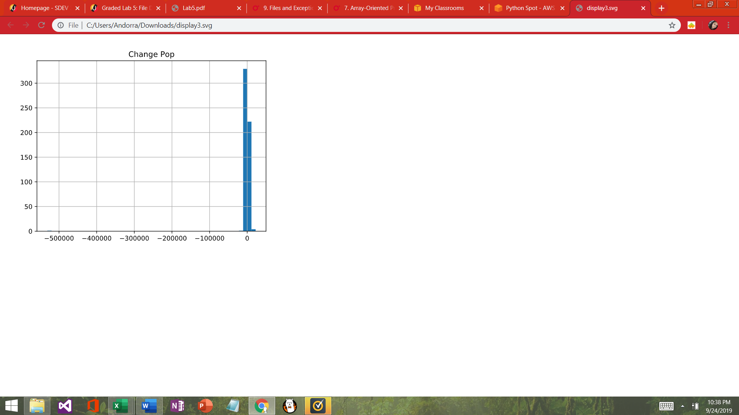

**2A**

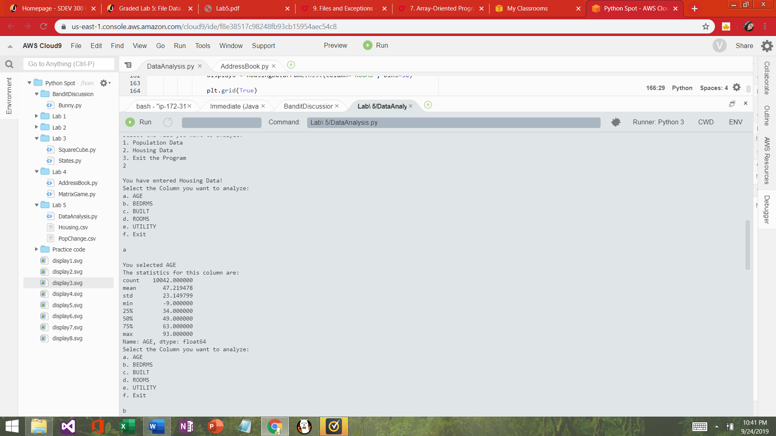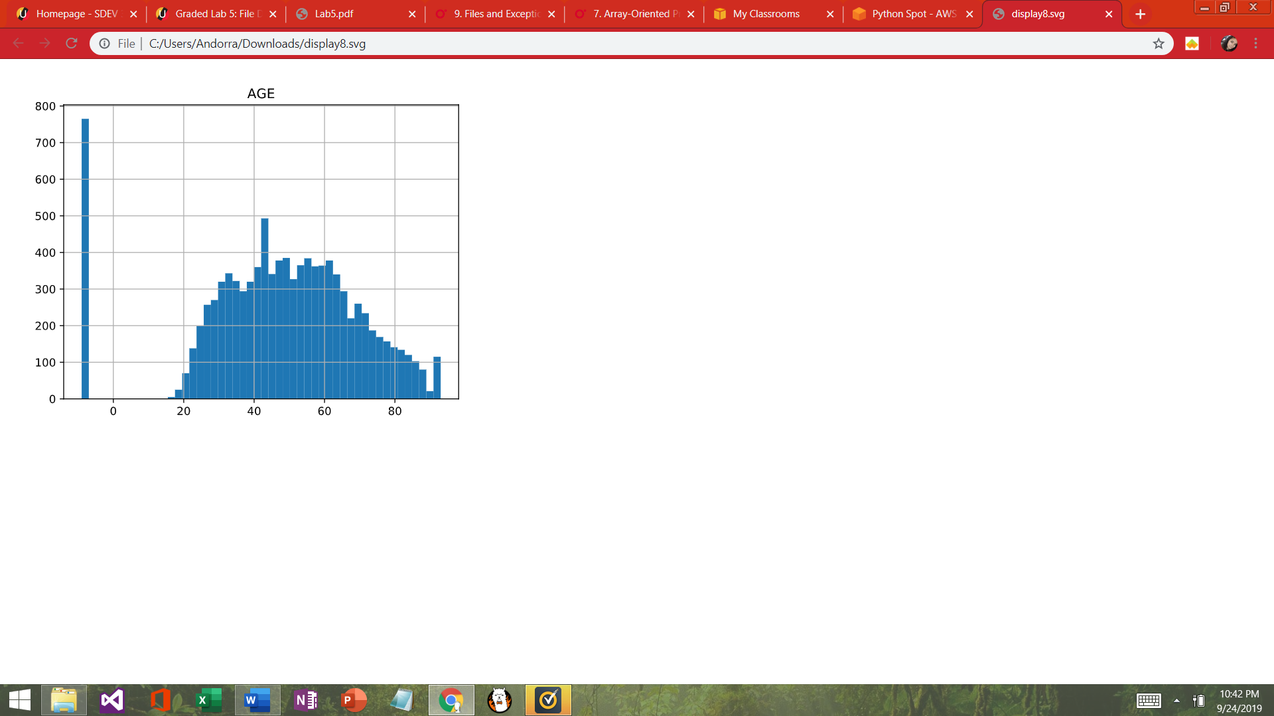

**2B**

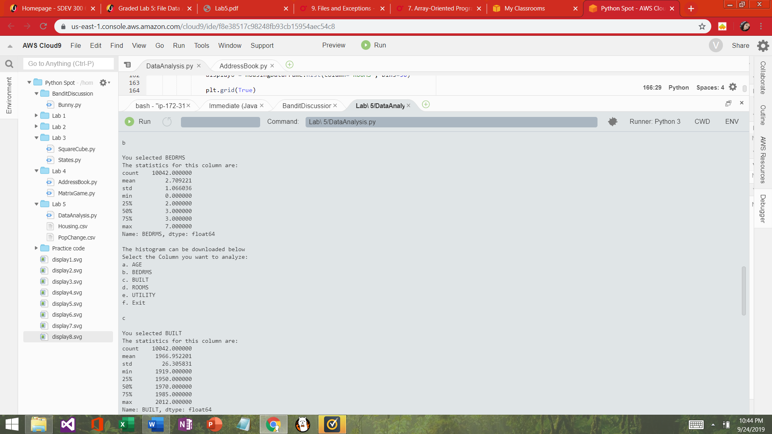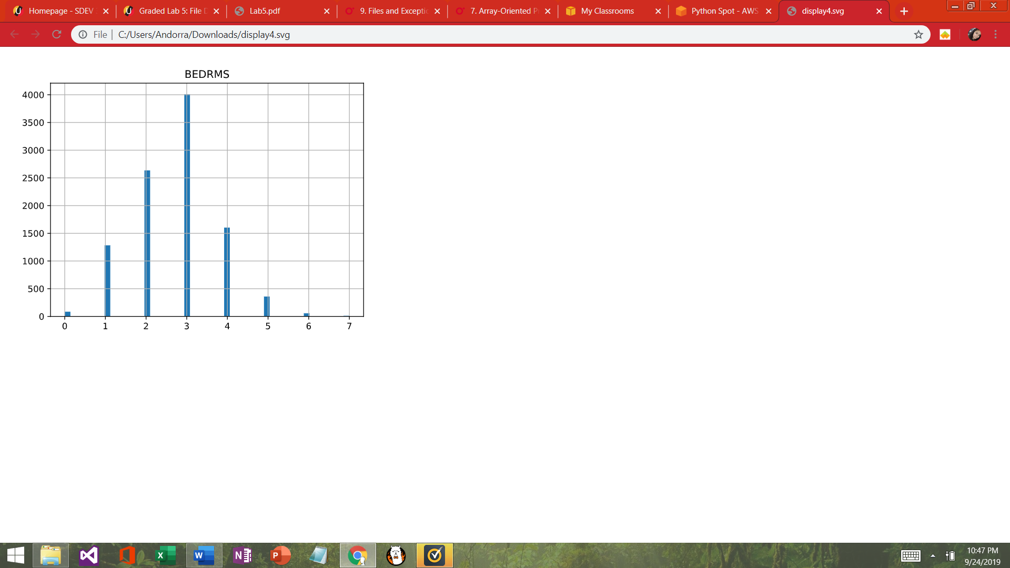

**2C**

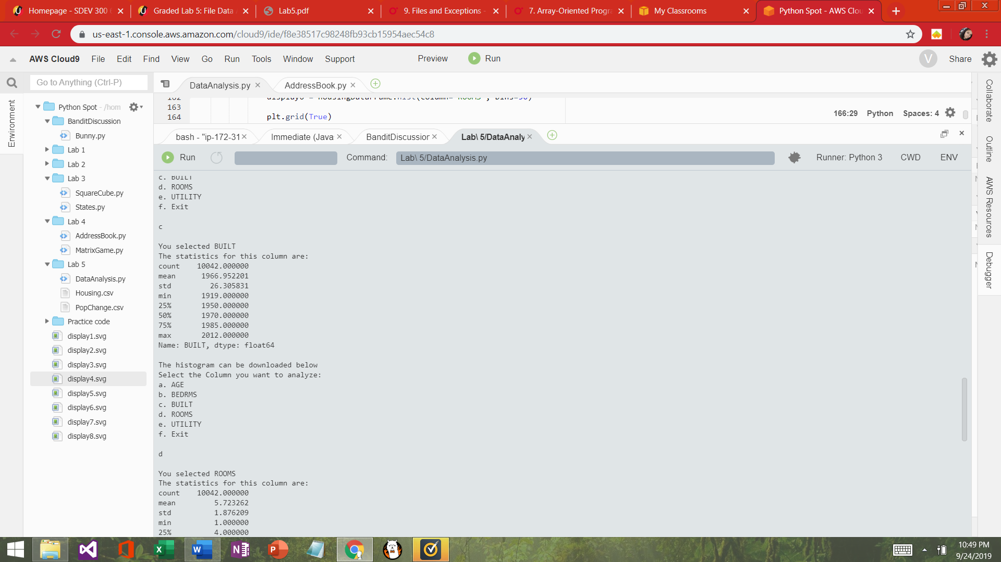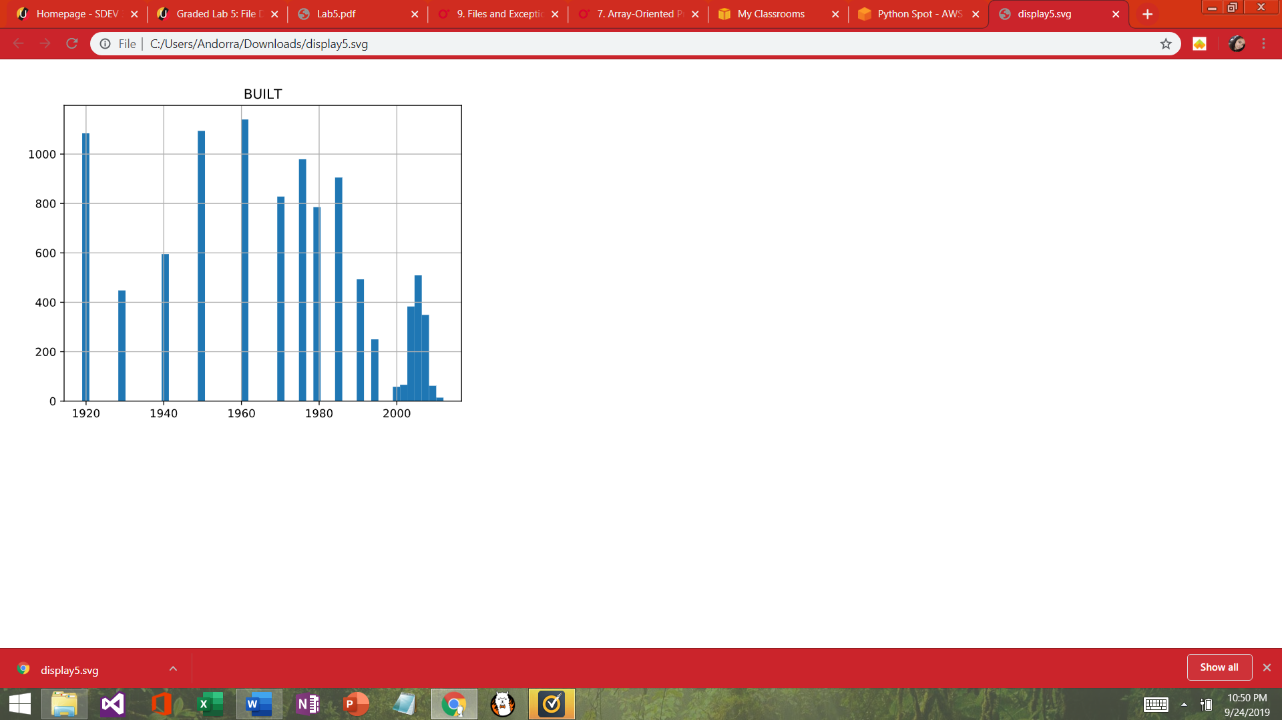

**2D**

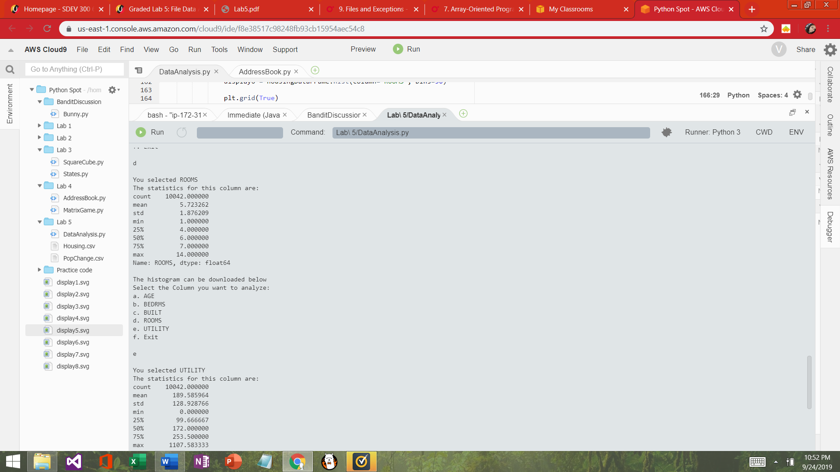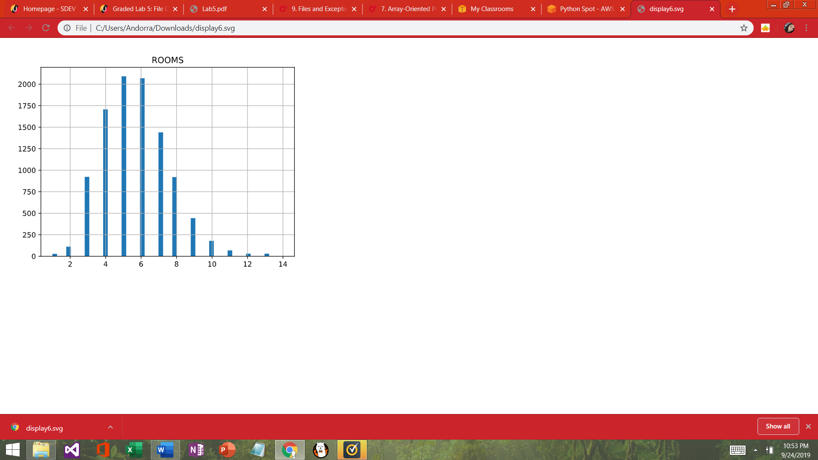

**2E**

